Assignment 2
Yaoding Chen

Code Available through Google Colab:

Question 1 Optimiser:
https://colab.research.google.com/drive/1fOA-eBGbcVTljZXZdjPnWKFQoQliyuQA?usp=sharing

Question 2 – Part 1 AutoEncoder:
https://colab.research.google.com/drive/1fOA-eBGbcVTljZXZdjPnWKFQoQliyuQA?usp=sharing

Question 2 – Part 2 Adversarial AutoEncoder:
https://colab.research.google.com/drive/1CfJkcDZX27Zj7qzErd4gkhkQbPjf7qpt?usp=sharing

Question 1
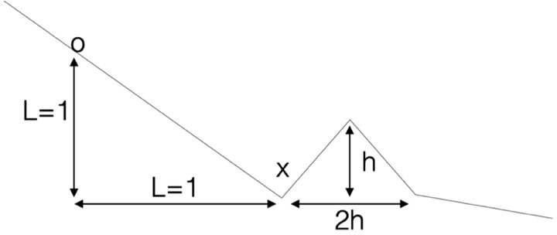
The diagram above shows a plot of a 1D function and gradient descend is applied to minimise the function at the point ‘o’. There is a bump a distance L away with bump dimensions given as h×2 h. Let L=1, a=0.3 and h> a, where a is the learning rate.

- what will happen if you apply standard gradient descend?

After a few steps, the cost function will converge to the local minimum x, instead of the global minimum, because the learning rate a is lower than h, which means each step is smaller than what is enough to detect another local minimum. Therefore, the function is trapped there.

- If you apply Adam optimisation with parameters given in the next slide, what is the max height ‘h’ of the bump in which the Adam optimiser will escape the local min at ‘x’? Use Ɛ=0 in instead of Ɛ=1e-8 in your calculations.

The maximum height is 0.41. Please see the attached code.¹

¹ https://colab.research.google.com/drive/1h6PmBW0c9vbGX0XCqCuOrGDEK7Ee09PG?usp=sharing

Question 2

  - Design an auto encoder to take in MNIST images with latent space dimension of
2 ,16 ,256. Train auto encoder with L1-norm reconstruction loss.

Please see the attached code.²

Do a 2D plot of the latent space for different digits for latent space of 2. K-means clustering for latent space of dimensions 16 , 256. Use one color for each digit.

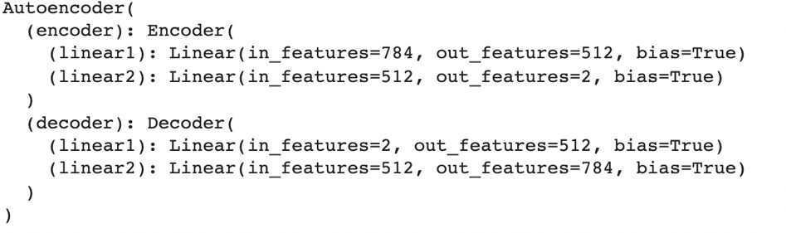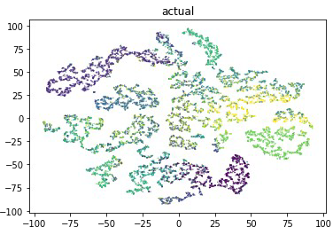Dim =2: the result shows no clear clustering, suggesting little information learnt.
Dim = 16: the result shows clear clustering. k-mean clustering results are unstable due to random centroids, but I managed to choose one that is closest to the actual results, which is not easy to get unless trying many times.
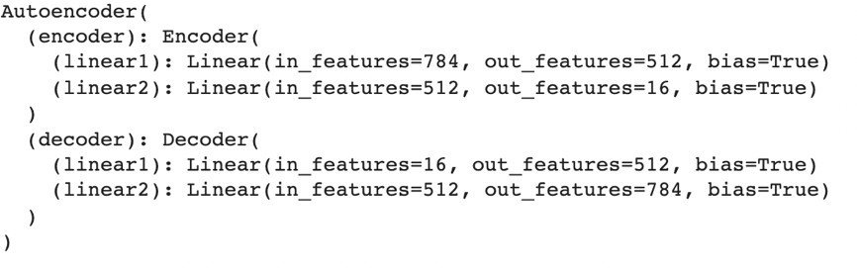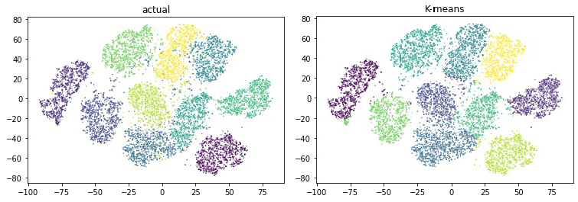

² https://colab.research.google.com/drive/1fOA-eBGbcVTljZXZdjPnWKFQoQliyuQA?usp=sharing

Dim = 256: it seems that little information is learnt and correctly summarised in the latent space, and the k-means results are poor, although it shows some kind of shapes we expect as a result of auto-encoder learning.
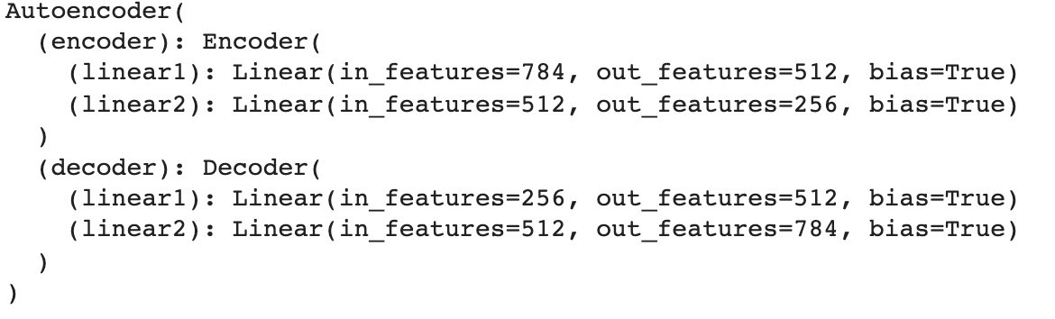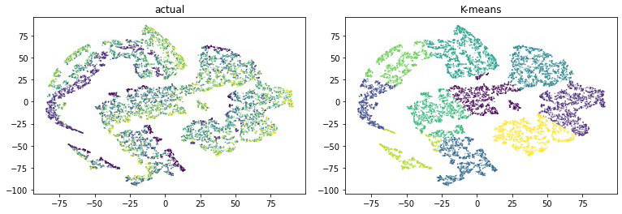

Report all results. What do you notice about the reconstructed images?

The images reconstructed in the latent layer seem to be a blurred, distorted version of the original images, which may indicate certain information loss. As shown below, it is getting blurer with the increase of latent layer size from 2 (left) to 16 (middle) to 256 (right).

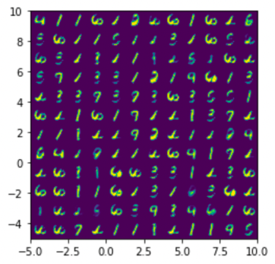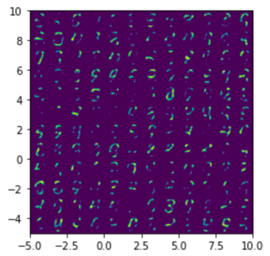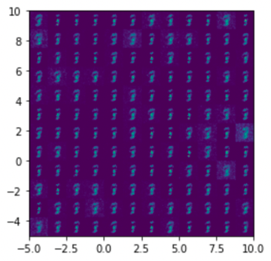

  - Design another neural network “dis_net” to discriminate between blur images and clear images. Blur images can be generated by taking the original MNIST data and do some gaussian blur.

Train autoencoder with L1-norm reconstruction loss + discriminator loss. Make reconstructed images as clear as possible, that is, the auto encoder will need to be trained so that “dis_net” score it as a clear image.
Compare results between (a) and (b)

Latent layer size = 2
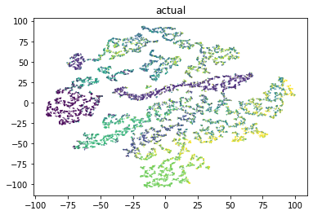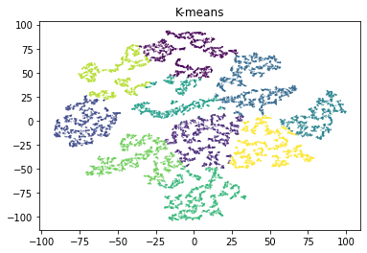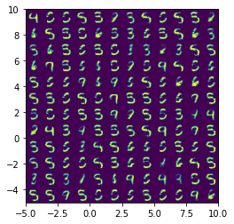

Latent layer size = 16
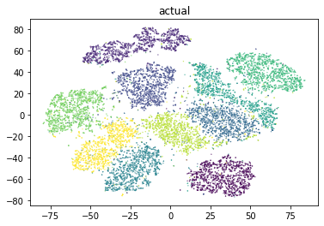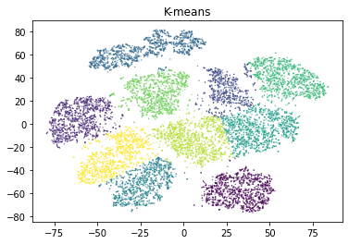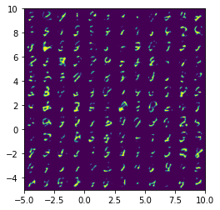
Latent layer size = 256
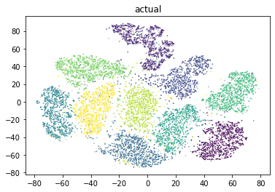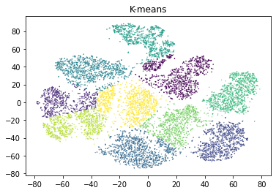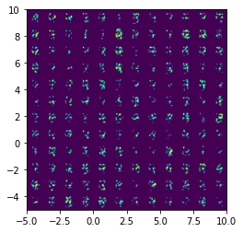

Please see the attached Jupyter Notebook for implementation. We train the model for 10 epochs. I think k-means results will be better when we give it more shots in the figures with latent layer sizes of 16 and 256. However, the reconstructed figures are not as clear as when the latent layer size is just 2, but it is clearer than when there is no discriminator. But still it seems that k-means is much easier to get correct clusters with layer size 16.

